**New features for the next firmware**

**Test the scenario**

**(MQ4** **stereotyped).**

Written: ________

Validation: __________

Audit: __________

Date: Year Month Day

**First, the purpose of the test**

The MQ4 project has been finalized, and the following 6 new functions have been added to the next computer. In the case of ensuring the normal operation of the instrument, verify whether the new functions of the next computer are realized, which is extremely stable.

1. Remove the upper overshoot of the first loop. For example: when the prenaturation is 90 °C and the denaturation is 97 °C, because the denaturation temperature is greater than the predetermination temperature, the previous procedure is that when the predetermination enters the denaturation, there is no overshoot, and there is no transgression after the change Punch, the normal cycle stage is still overshoot;

2. Auxiliary heat is adjustable. The temperature rise is turned on at the beginning and closed 6 s before the start of the cooling, ---- improve the temperature uniformity between the pores

3. Peltier over-temperature protection. In a certain period of time, the peltier does not reach the target temperature, the instrument is protected, and the experiment is stopped; ---- improve the safety of the instrument

4. Thermal cover over-temperature protection. In a certain period of time, the heat cover does not reach the target temperature, the instrument is protected, and the experiment is stopped; ---- improve the safety of the instrument

5. Auxiliary heat temperature setting value: 98 °C, ---- improve the temperature uniformity between the pores

6. Increase the number of pre-denaturation stages. The maximum number of prenaturation stages is 8. Different working modes are ---- available

1. **Test environment**

The tools used in this experiment are shown in Table 2-1.

Table 2-1 Test tools

|  |  |  |
| --- | --- | --- |
| **Name of property fee** | **Number (pcs**). | **remark** |
| MQ4 instrument | 5 | 1. Host version: anitoa-1.7.0.20 2. Next BIT version:   Host：1.host105_V1.49  Temp：2.thermalControl_V1.74  Image：3.img_alpha_V1.50 |
| Power adapter | 5 | Mingwei, 16V |

1. **Test the steps**

**3.1 Remove the overshoot on** **the first cycle (denaturation** **-** annealing).

3.1.1 During the normal temperature control experiment, the predetermination is set to 90 °C, the denaturation is set to 97 °C, and the overshoot parameters are set at the same time, and the remaining parameters are unchanged, and the experiment is started;

3.1.2 Observe the temperature control curve (pre-denaturation - > denaturation) of the first cycle, if the temperature control curve is as shown in Figure 3-1-1, the function cannot work properly, verify "unqualified"; if the temperature control curve is as shown in figure 3-1-2, then the function can work normally, verify "qualified";

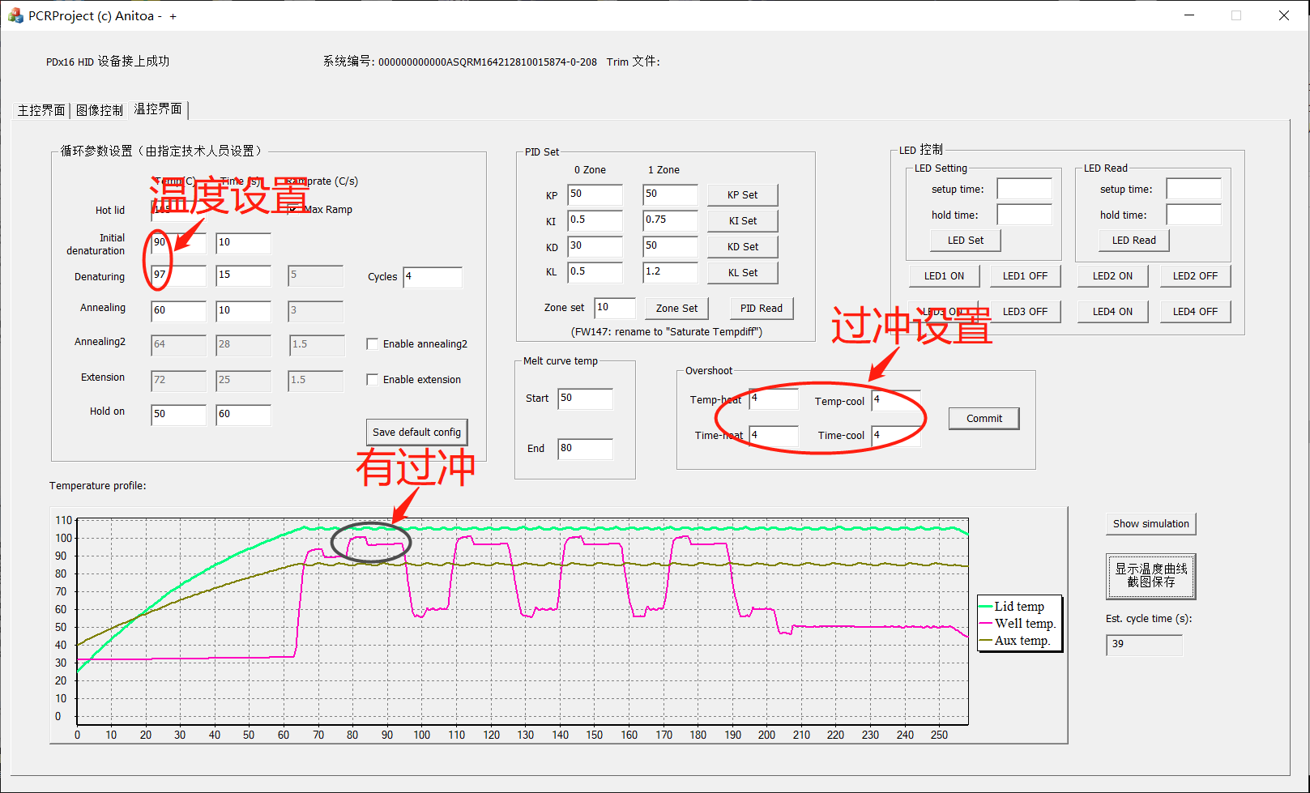

Fig. 3-1-1 The overshoot function on the first cycle (denaturation - annealing) is removed and failed

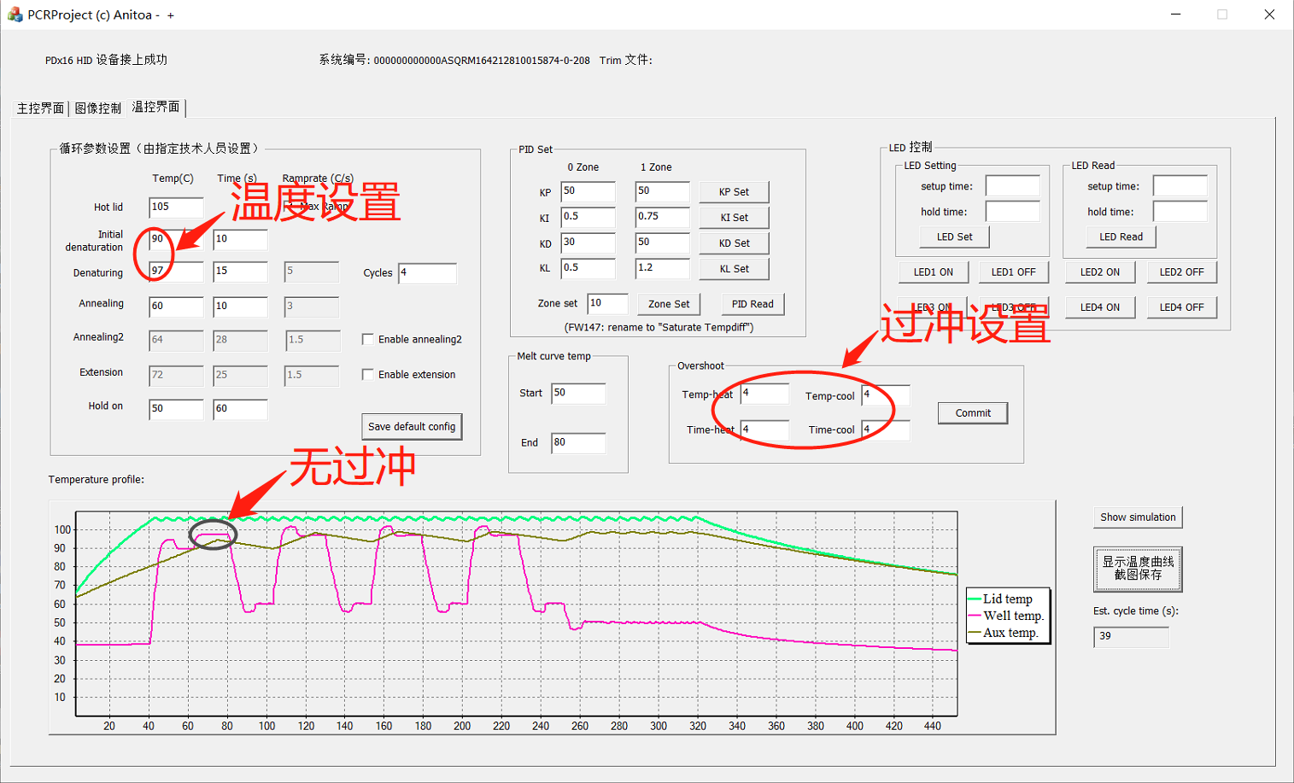

Fig. 3-1-2 The overshoot function on the first cycle (denaturation - annealing) is verified

3.1.3 Conduct a round of experiments with 5 instruments and record the experimental results.

**3.2 Auxiliary heat adjustable**

3.2.1 During normal temperature control experiments, observe the auxiliary heat temperature control curve. If in the cyclic process (denaturation - annealing), the auxiliary heat is turned off 6s before the end of denaturation and opened at the end of the annealing, the function can work normally and verify "qualified", as shown in Figure 3-2-1; otherwise, the function cannot work properly and verify "unqualified";

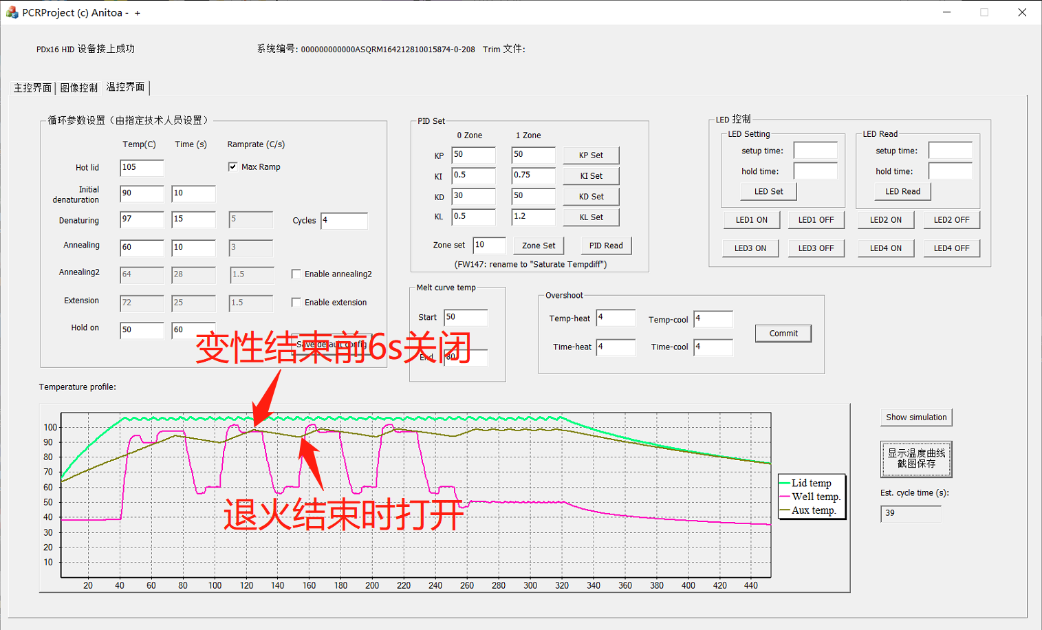

Figure 3-2-1 The auxiliary thermal function is verified

3.2.2 Conduct a round of experiments with 5 instruments and record the experimental results.

**3.3 Peltier overtemperature protection**

3.3.1 During the normal temperature control experiment, observe whether the instrument is working properly; if the instrument is working normally, the verification is passed, as shown in Figure 3-3-1;

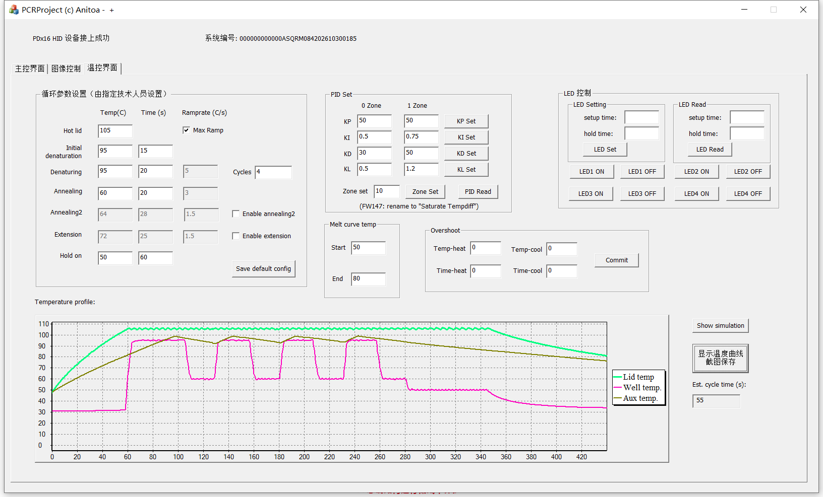

Figure 3-3-1

3.3.2 Disconnect the connection between the switch board and the peltier, start the temperature control experiment, observe the equipment status (temperature control curve, running indicator); if the heat cover reaches 105 ° C for a period of time, the experiment stops, the verification passed, as shown in Figure 3-3-2;

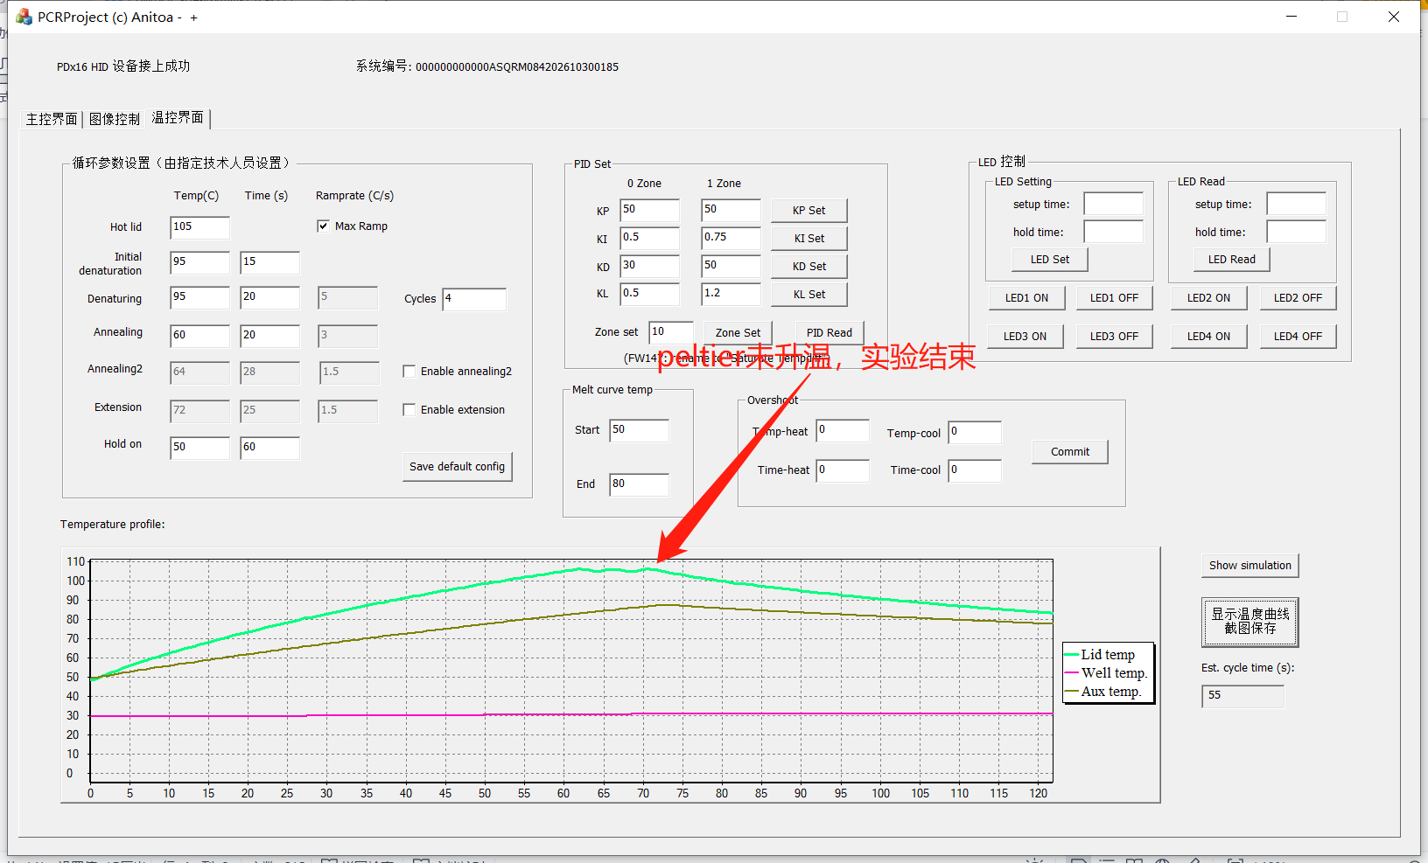

Figure 3-3-2

3.3.3 Connect the peltier to the switch plate, start the temperature control experiment, and at a certain heating stage of the peltier (the peltier does not reach the target temperature), Disconnect the connection between the circuit board and the peltier to observe the state of the device; if the experiment stops after a period of time, the verification is passed, as shown in Figure 3-3-3;

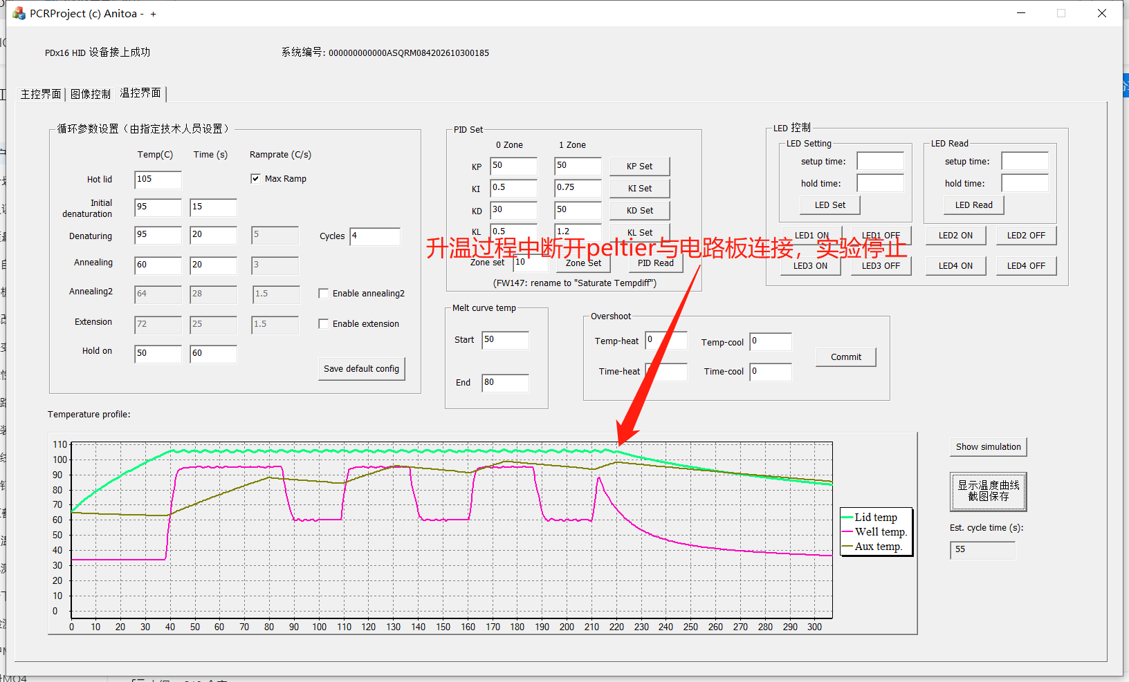

Figure 3-4-3

3.3.4 Connect the peltier to the switch board, start the temperature control experiment, in a certain denaturation stage, disconnect the connection between the circuit board and the peltier, observe the state of the device; if after a period of time, the experiment stops, the verification is passed, as shown in Figure 3-3-4;

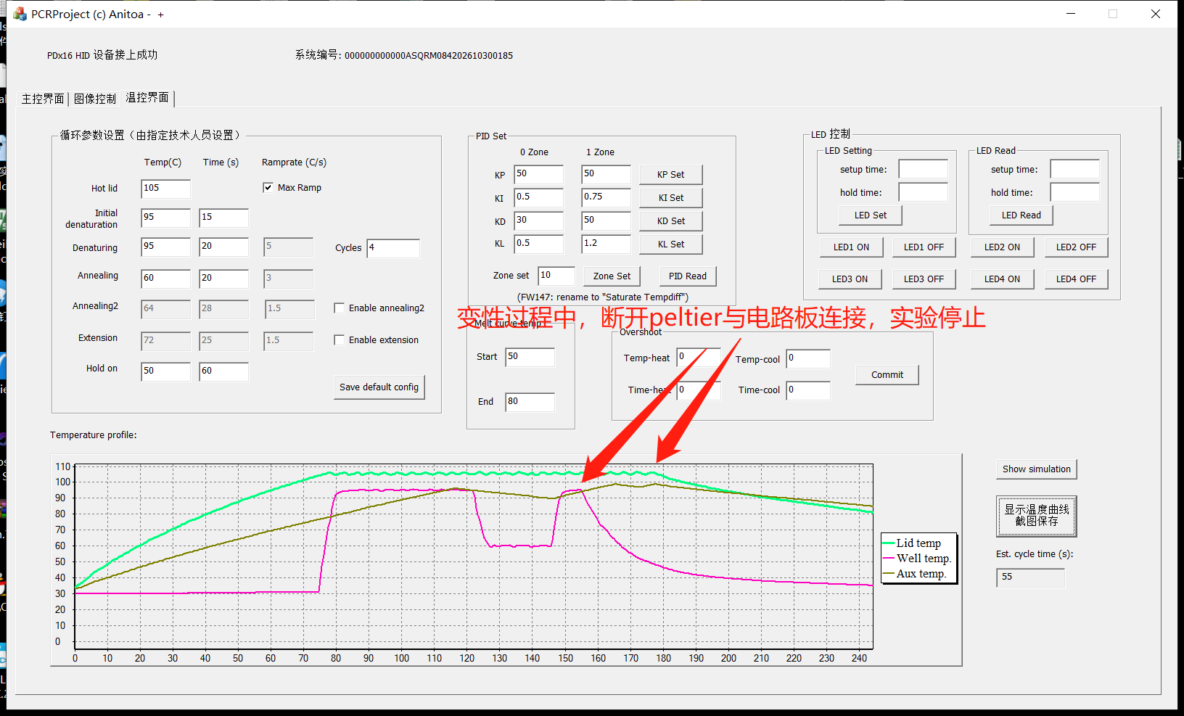

Figure 3-3-4

3.3.5 Connect the peltier to the switch plate, start the temperature control experiment, and at a certain cooling stage of the peltier (the peltier does not reach the target temperature), Disconnect the connection between the circuit board and the peltier to observe the state of the device; if the experiment stops after a period of time, the verification passes, as shown in Figure 3-3-5;

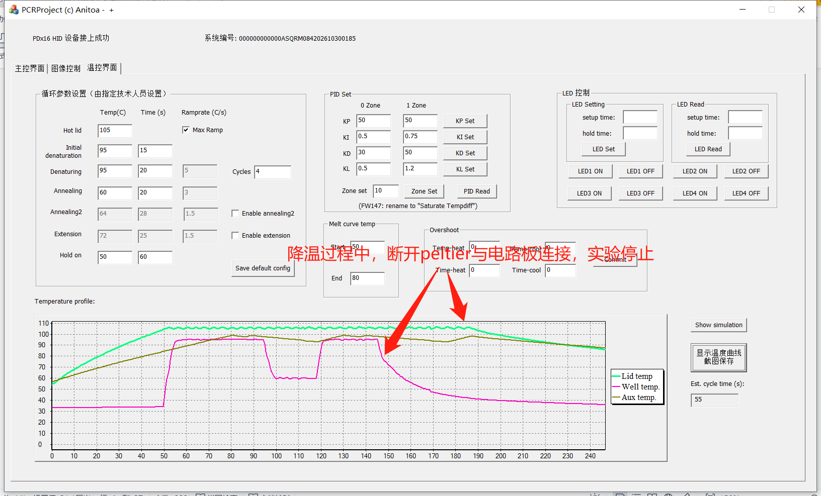

Figure 3-3-5

3.3.6 Connect the peltier to the switch board, start the temperature control experiment, in a certain annealing stage, disconnect the connection between the circuit board and the peltier, observe the state of the equipment; if after a period of time, the experiment stops, the verification is passed, as shown in Figure 3-3-6;

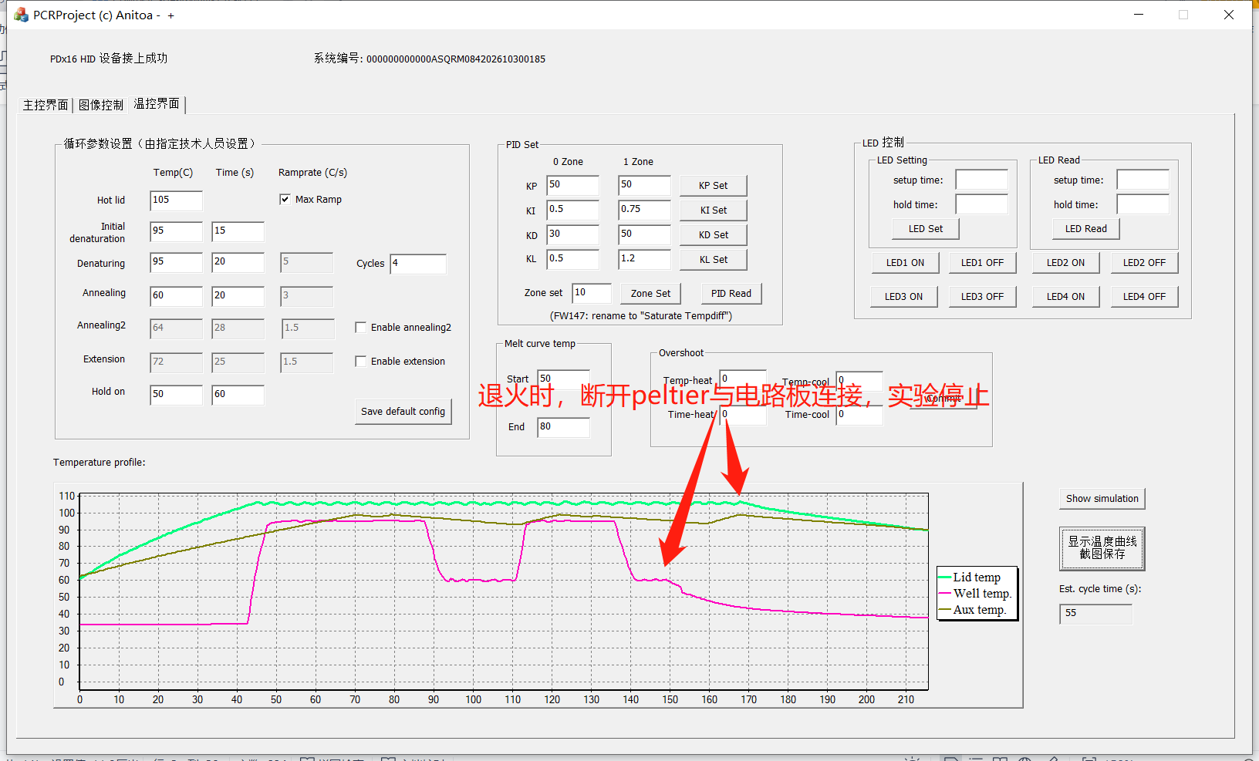

Figure 3-3-6

3.3.7 Use 5 instruments to carry out a round of experiments according to steps 3.3.1~3.3.6, and record the experimental results. If each of the items in 3.3.1~3.3.6 is verified, the function can work normally and verify "qualified"; otherwise, the verification is "unqualified".

**3.4 Over-temperature protection of the hot cover**

3.4.1 During the normal temperature control experiment, observe whether the instrument is working properly; if the instrument is working normally, the verification is passed, as shown in Figure 3-4-1;



Figure 3-4-1

3.4.2 Disconnect the connection between the opening and closing board and the heat cover, start the temperature control experiment, observe the equipment status (temperature control curve, running indicator); if after a period of time, the heat cover does not heat up, the experiment stops, the verification is passed; (This item can be judged by observing the operation indicator: after starting the experiment, the running indicator light is on, indicating that the equipment is working; after a period of time, the operation indicator is off, indicating that the equipment stops working).

3.4.3 Connect the heat cover to the switch plate, start the temperature control experiment, disconnect the connection between the circuit board and the hot cover during the heating stage (the heat cover has not reached the target temperature), observe the state of the device; if the experiment stops after a period of time, the verification is passed, as shown in Figure 3-4-2;

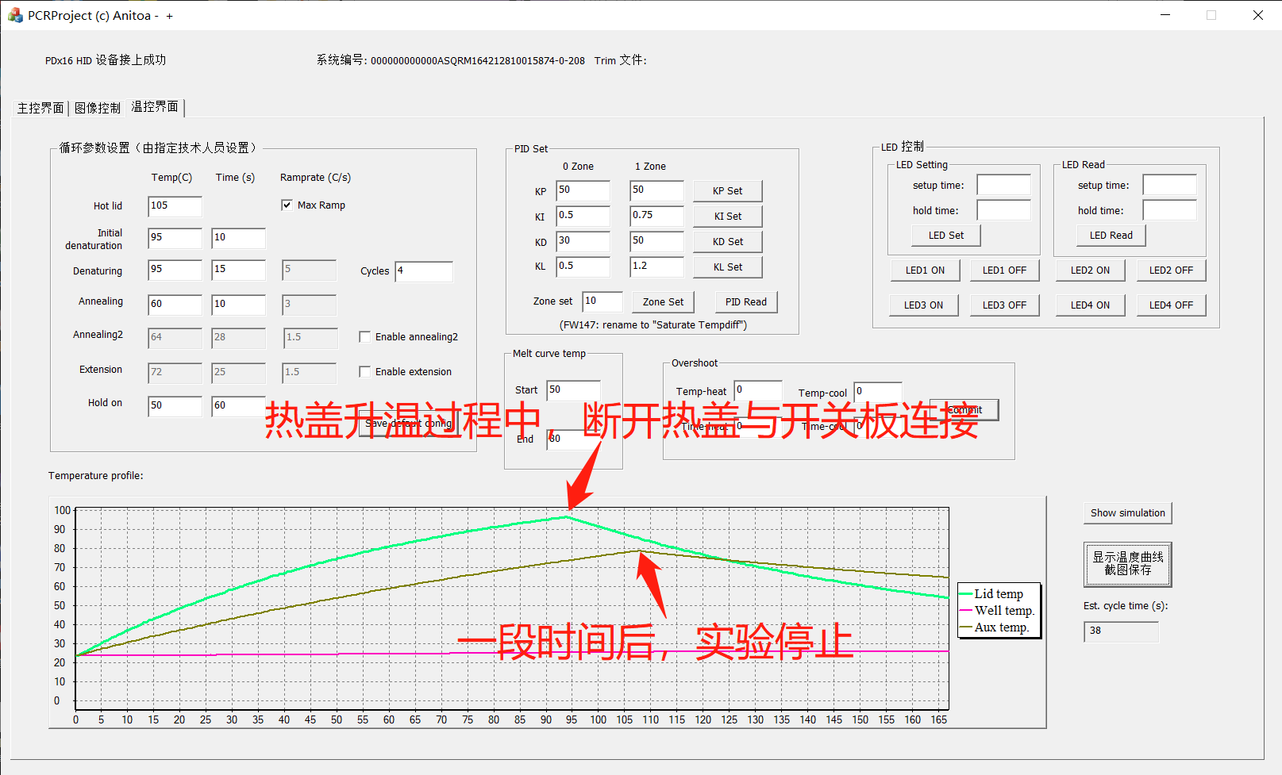

Figure 3-4-2

3.4.4 Connect the heat cover to the switch plate, start the temperature control experiment, disconnect the connection between the circuit board and the hot cover at a certain moment after the hot cover reaches the target temperature, and observe the state of the device; if the experiment stops after a period of time, the verification is passed, as shown in Figure 3-4-3;

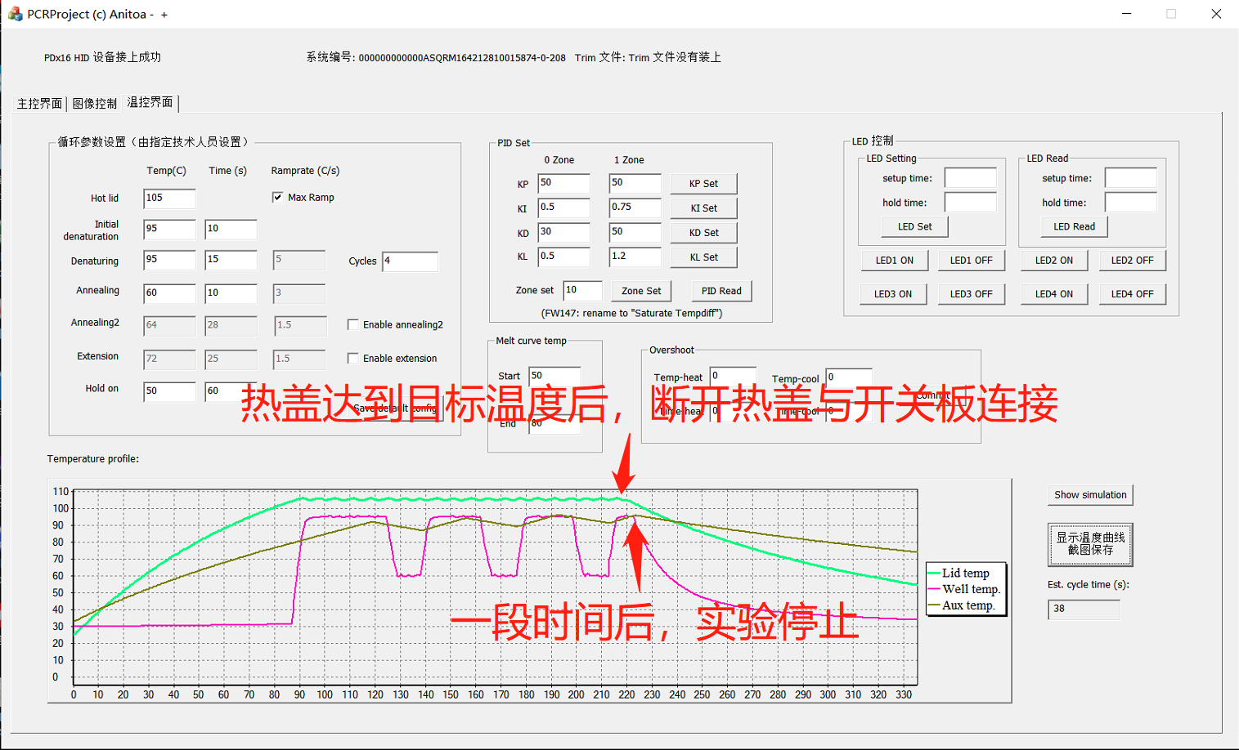

Figure 3-4-3

3.4.5 Use 5 instruments to carry out a round of experiments according to steps 3.4.1~3.4.4 and record the experimental results. If each of the items in 3.4.1 to 3.4.4 is verified, the function can work normally and verify "qualified"; otherwise, the verification is "unqualified".

**3.5 Auxiliary heat temperature setting value (98°C**).

3.5.1 During normal temperature control experiments, observe the auxiliary heat temperature control curve. If the target temperature of the auxiliary heat is 98 °C, verify "qualified", as shown in Figure 3-5-1; otherwise, verify "unqualified";

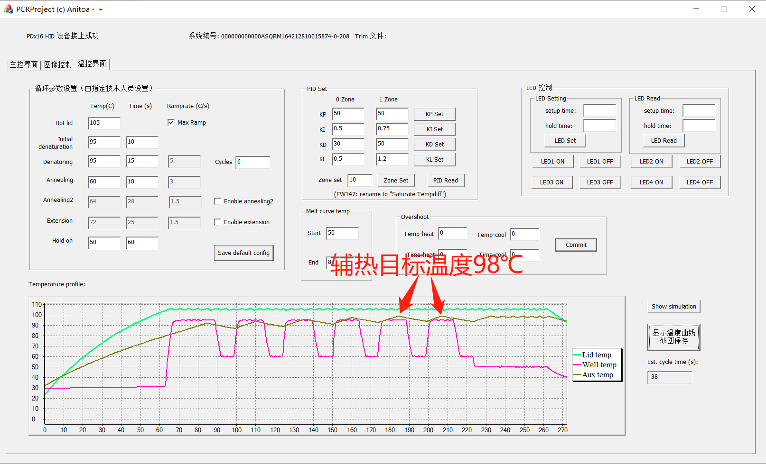

Fig. 3-5-1 The target temperature of the auxiliary heat is 98 °C

3.5.2 Conduct one round of experiments with 5 instruments and record the experimental results.

**3.6 Increase the number of prenaturation stages**

3.6.1 During normal temperature control experiments, increase the number of predetermination stages (not less than 3, not more than 8) and observe whether the instrument is working properly. If the test status is consistent with the settings, verify "passed", as shown in Figure 3-6-1; otherwise, verify "failed";



Fig. 3-6-1 The experimental status is consistent with the settings

3.6.2 Conduct a round of experiments with 5 instruments and record the experimental results.

**3.7 Comprehensive Testing**

After the above 3.1~3.6 function verification is completed, the fatigue test verification of the conventional function of the instrument is required.