The main CPU of the Maverick qPCR instrument is a 32-bit ARM based embedded processor (STM32 105 series). It contains firmware as well as device specific data. Both are programmed in the factory before product shipping. Here is the step1 to perform update of the firmware.

Requirement:

* Anitoa’s “Factory Software”.
* Segger Jlink software.

Procedures:

Step1: Connect the qPCR instrument to the PC and Launch the Factory Software. When prompted to download the flash data to the PC, click yes.

Step 2: Go to the “Imager parameters” page, go to the lower right corner and click on “Save Flash Image”. Save the flash image file. The default file name contains the device’s ID information for easy retrieval.

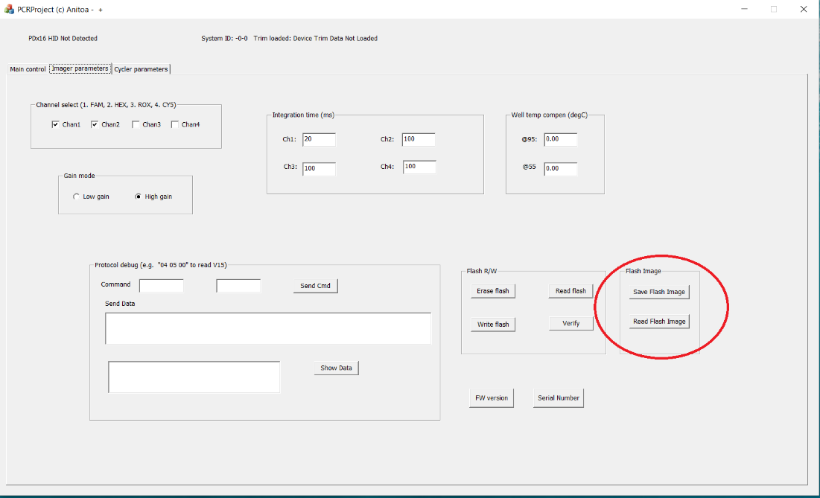

Step 3: Disconnect and power off the instrument. Then connect the firmware programmer and follow steps to program the firmware.

Step 4: After the firmware is updated, disconnect and power off the instrument again. Connect the instrument to PC, apply power and launch factory software again. Go to the “Imager parameters” page, go to the lower right corner and click on “Read Flash Image”. Load the flash image file corresponding to this instrument.

Step 5: Go to the “Imager parameters” page, click on “Write Flash” to write the device data to the flash memory of the main CPU.